**Top 10 Programming Tips for Beginners**

Last Updated : 29 Jan, 2024

Whether you are a novice or have just started to [learn programming](https://www.geeksforgeeks.org/programming/), there are key tips that can significantly enhance your learning experience. In this blog post, we’ll explore the top 10 programming tips for beginners that can help you build a strong foundation and navigate the complexities of coding with confidence.

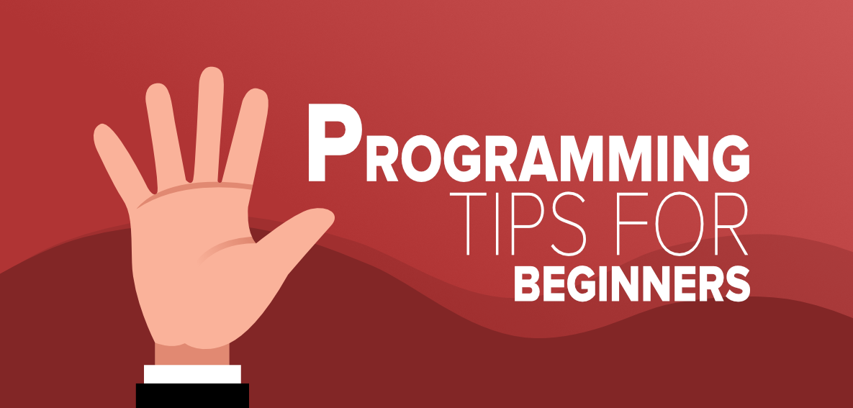

**Top 10 Programming Tips For Beginners**

Most of the students have dreams to build their own applications or software and that makes them driven to learn to code. With full enthusiasm, they also start learning to code picking up some programming language but in most cases, students get frustrated because of the difficulty they face while making some programs and it also becomes boring for them.

The reason why it happens is a lack of guidance. They follow some wrong strategies and make mistakes while learning to program. We are going to discuss some **tips which students should follow to learn programming** in a better way to avoid all those mistakes.

**1. Apply Your Theoretical Knowledge Practically (Practice, Practice, Practice…)**

Most of the students only consume theoretical concepts and avoid practicing problems. They watch youtube tutorials, attend some classroom programs and think in a way that they understood everything so they don’t need to practice for the coding questions. This is one of the worst mistakes beginners always make in programming. You won’t be able to solve the mathematics question in your exam if you only remember the maths formula, the same thing happens in coding. Get your hands dirty in programming and don’t skip the question in exercises thinking that it’s easy so no need to write the program.

A lot of students also think that coding questions are tough for them. The reason is their brain is not trained enough to solve those questions. When you practice enough for the coding question the response time is reduced for your brain and you eventually get the logic to solve the problem.

***How Practical is Important in Programming:***

* *You become habitual of syntax and gain typing speed.*
* *You need to think a lot to solve problems in coding so it eventually develops problem-solving skills.*
* *It helps in getting the logic quickly to solve the problems.*
* *You become aware of common programming problems.*

**2. Don’t Leave a Gap in Your Learning**

This is another common mistake most newbie programmers make…irregular learning. They teach themselves to code for two days and on the third day, they skip it which breaks the rhythm of programming. Maintain consistency, make programs every single day, and face new programming challenges in your daily learning.

Facing new challenges in programming reduces the response time of your brain which helps in getting the logic quickly. It also teaches you how to think and solve more complex problems which are really valuable in industries (***problem-solving skills***) and useful in solving real-life problems as well. You can take the help of any textbook to solve the problems or you can also practice on [GeeksforGeeks](https://www.geeksforgeeks.org/), HackerRank, and Codecademy site.

**3. Don’t do Over Analysis of the Concept**

Most of the students or newbie programmers overanalysis of concepts in programming which is another mistake. They don’t move to the next chapter and waste their time on a single concept. Having a good command of a specific topic is good but overanalysis can make you the worst programmer and your progress will be slow.

You won’t be able to complete the target within a deadline so understand and grasp the topic in a simple way, use the concept practically, and move further. Analyzing a concept in-depth for the first time is not good, once you have enough experience you can go in-depth for the specific concept.

**4. Read The Error Message Carefully**

A lot of beginners don’t pay attention to the errors given on the screen and ask for help from their mentors or senior programmers immediately. Understand that errors on the screen say a lot about the issues and you can find the solution from there as well if you read the error message carefully. Not from all the errors you can find the solution but before asking for help pay attention to it. If you don’t get the solution, just search on the internet for the error message.

**5. Solve the MCQs Questions in Programming**

If you are learning to program for the first time solve MCQs as much as you can. You can find a lot of MCQs or debugging-related questions on the internet. It will help you in campus interviews and off-campus as well. Making a program develops logical thinking ability but solving the MCQs question helps in making good commands on syntax and you start understanding some important rules in programming. It also helps in analyzing how a program behaves in different kinds of situations. So don’t ignore the importance of MCQ questions and practice it daily to clear your concepts in programming.

**6. Code With Hands**

It is highly recommended that you use pen and paper while coding and if you are a beginner then it is quite necessary. However, usually, people do coding on computers but when you use your hands then you are able to process things faster. Technical evolution can also be done at a faster pace and you learn it quickly.

If you have done coding with your hands then it will also be helpful in the future as at the time of interviews the person sitting in front of you might ask you to write down a code, then you can do it in minutes, faster than a person who only uses computers for coding.

**7. Read Other People’s Code**

Knowledge does not go in vain! It’s true that you should practice programming and coding on your own but reading codes by other people is very helpful. People make the common mistake of not reading programs done by someone else as they think that it is something wrong, but it’s not true. Reading new things allows you to find solutions to problems that you found tough or were not able to do after many attempts. Doing this helps you to find the solution faster and save a lot of time.

**8. Enhance Your Problem-Solving Skills**

It is very essential that you work on your problem-solving skills as it is one of the most important skills as a developer. You might think that experienced web developers would not get stuck in any place or would not have any problems while solving any problem. But that is not right, they enhance their problem-solving skills by working constantly and do not leave it in the middle. Also, errors are common, so do not get disheartened, just continue your process. You can also take help from any book or the internet in order to get perfect results.

**9. Divide Things into Smaller Parts**

Everyone wants to finish their task on time, but when you are doing programming it’s totally the opposite—You have to take time in order to complete the work properly (that is without mistakes). It can be contradictory but it is important if you are a beginner, you should know how to divide your time in a way that is correct and gets completed on time. You should start with the basics and then go up level by level. Doing so will keep things sorted otherwise things will be hassled up and you will not get any results. Also, keep on exploring different learning methods as they will enhance the complete process of learning something new.

**10. Find a Perfect Mentor**

For beginners, finding a mentor would be perfect as they will be guided properly from the start. The mentor should be an actual who should have proper knowledge about the things that you want to learn. He/she must be able to guide you in the right direction and explain problems by providing them with solutions. Having a mentor will definitely increase your speed of learning things that too in flow and if you are stuck somewhere they will also help you to solve it. Apart from this, you might also join a community where there are numerous experts who work together and help each other to grow. There you can also become a part of numbers competitions for programmers and gain knowledge.

**Conclusion**

Remember that ***learning the first programming language always requires special effort***. Programming also needs a lot of patience and practice. Initially, you will struggle and you will try to give up but that’s the moment when you need to have the patience to solve the questions.

Your brain needs exercise to solve questions in programming and it will only come with practice. Start with smaller problems and train your brain to solve simple problems first then move to the next level or some complex problem. You can’t solve the mathematics problems of the 10th standard if your brain is not trained enough to solve the problems of the 9th standard. So don’t skip the question and move level by level in coding.